**aidhp-tensor-titans**

**1. Introduction**

**1.1 Overview**

The hackathon challenge aimed to develop an AI-driven hyper-personalization system for the financial sector. The goal was to generate highly personalized product and service recommendations by analyzing customer profiles, purchase history, social media, and sentiment data.

**1.2 Objective**

Our solution focuses on:

* Predicting customer metrics (churn rate, financial potential, risk appetite, profits generated for bank)
* Recommending customers relevant financial products.
* Using GenAI-powered sentiment analysis to refine those recommendations.
* Providing actionable insights for banks to optimize engagement and boost revenue.

**2. Problem Statement & Use Case**

**2.1 Problem Statement**

Modern customers expect highly personalized experiences that cater to their unique preferences. In this hackathon, participants will develop a Generative AI-driven solution that enhances hyper-personalization by analyzing customer profiles, social media activity, purchase history, sentiment data, and demographic details. The challenge is to design a system that generates personalized recommendations for products, services, or content while also providing actionable insights for businesses to optimize customer engagement.

**2.2 Use Case**

The system will analyze customer data to generate personalized product and service recommendations. The recommendation engine will assess:

Customer-Specific Factors:

* Probability of the customer leaving the bank
* Potential revenue the customer can bring to the bank
* Customer’s risk appetite
* Financial literacy of the customer

Product and Service Factors:

* Risk to the customer
* Risk to the bank
* Profitability for the bank
* Value to the customer
* Lock-in period (customer retention potential)

Using these attributes, the AI model will first generate an optimal subset of financial products/services that maximize monetary value for both the bank and the customer. A second filtering step will further refine recommendations based on customer interests, preferences, and behavioral patterns.

Example Use Cases:

* A customer with frequent international travel and luxury hotel bookings is recommended a premium travel credit card with exclusive airport lounge access and cashback on travel expenses.
* A young professional with stable income and increasing monthly savings is offered a low-risk investment plan, whereas a high-net-worth individual with a diversified portfolio receives hedge fund recommendations.

This AI-driven approach will not only increase customer satisfaction but also help the bank optimize revenue streams and reduce churn rates through real-time, dynamic financial recommendations.

**3. Approach & Methodology**

**3.1 Dataset Details**

Our system processes diverse data sources to generate hyper-personalized financial product recommendations:

**Customer profile attributes:** Demographics, financial acumen, income range, and past interactions.

**Purchase history:** Financial transactions including spending patterns and product usage.

**Social media activity:** Posts and engagement levels that indicate sentiment and brand affinity.

**Customer support interactions:** Sentiment scores to gauge satisfaction and churn probability.

**Financial products data:** Various product categories (credit cards, loans, insurance) with multi-tier options. Each product has attributes such as risk score, revenue potential, customer value, and lock-in period.

**3.2 AI Model Selection**

We leverage multiple AI techniques for sentiment analysis, recommendation, and scoring:

**LLM API:** The system uses Google Gemini 2.0 Pro for NLP tasks such as extracting sentiment scores, interpreting customer interactions, and generating personalized recommendations.

**Distance-based models:**

1. **Mahalanobis Distance**: Used for mapping customer attributes (risk, profit, etc.) to product attributes by measuring the multivariate distance between them, ensuring personalized and contextually relevant recommendations.

2. **Weighted Vector Distance**: Used for refined ranking and filtering of products based on business-specific priorities. It applies custom weighting factors to emphasize certain metrics (e.g., profit, retention), making the recommendations more business-driven and strategically aligned.

**3.3 Feature Engineering & Data Processing**

**Customer Metrics Generation**

The system generates four key customer metrics by processing customer activity data:

**Churn Rate**: Probability of the customer leaving the bank. Calculated based on negative sentiment in support queries and low engagement on social media. It also checks a decrease in bank balance, and spending (from that bank’s account / credit card) indicating a probable switch to a different bank.

**Profit Generated**: The monetary value the customer brings to the bank, derived from income, spending behavior, and transaction history.

**Risk Appetite**: Customer’s willingness to take financial risks, inferred from their investment, spending patterns and defined goals.

**Financial Acumen**: Measures the customer’s financial knowledge and experience, determined from their transaction types and social media interactions.

**Product Attributes**

Each financial product has five key attributes:

**Risk to Customer**: The level of financial risk posed to the customer.

**Risk to Bank:** The potential risk the product poses to the bank in terms of defaults or losses.

**Revenue Potential**: The profitability of the product for the bank.

**Customer Value**: The benefit or appeal of the product to the customer.

**Lock-in Period**: The duration for which the customer is committed to the product.

**3.4 Mapping and Recommendation Workflow**

**Mapping Customer Metrics to Product Attributes**

To create meaningful and personalized recommendations, the system matches customer profiles with product characteristics. This mapping process involves analyzing several key factors:

* Risk for the Customer: Assesses product risk suitability based on the customer’s risk appetite and financial acumen.
* Value to the Customer: Prioritizes products with better benefits and manageable complexity.
* Profit Margin for the Bank: Identifies lucrative products suitable for the customer’s financial proficiency.
* Risk to the Bank: Deprioritizes products with potential losses or high-risk exposure.
* Retention Value: Factors in churn risk and future revenue potential to recommend competitive products.

**Recommendation Pipeline**

The workflow consists of two stages:

* Initial Filtering (Financial Suitability):
  + Distance-based algorithms measure how well products match the customer’s profile.
  + Mahalanobis distance is the primary metric; the system switches to weighted vector distance to generate passive recommendations which are focused more on customer retention and low risk and less on profits.
  + Products closely aligned with the customer’s profile are shortlisted, while excessively risky options are filtered out.
* Final Recommendation Refinement (Personal Preferences):
  + LLM-powered NLP ranks products based on recent activities, interests, and sentiment insights.
  + Social media and support sentiment data refine recommendations to match the customer’s emotional state and preferences.

​**4. Model Training & Hyperparameter Tuning**

**4.1 Model Architecture & Configuration**

LLM-based NLP API:

* + Sentiment analysis and final product ranking are powered by LLM API calls (Google Gemini 2.0 Pro).
  + The API handles:
    - Sentiment extraction from customer support interactions and social media posts.
    - Generating personalized product recommendations based on preferences and real-time interactions.

**4.2 Training Data Pipeline**

Since the solution primarily uses distance calculations and API-driven NLP rather than custom-trained models, the data pipeline focuses on:

* Data Ingestion:
  + Customer and product data are loaded from CSV files using the Flask API.
  + The data is preprocessed into structured formats for metric calculations.
* Sentiment Updates: When customer support or social media data is updated:
  + The system triggers sentiment analysis using the update_sentiments.py module.
  + The LLM API generates new sentiment scores and updates them in the corresponding CSV files.
* This ensures that the system dynamically reflects customer sentiment changes in recommendations.

**5. Ethical Considerations & Bias Mitigation**

**5.1 Bias Mitigation Practices**

Our solution is designed with adaptive and dynamic mechanisms that help reduce the risk of bias and ensure fair recommendations:

* Sentiment-Driven Personalization:
  + By incorporating real-time sentiment analysis from customer support and social media interactions, the system continuously refines recommendations.
  + This ensures that the solution adapts to changing customer preferences and avoids static or outdated biases.

**5.2 Data Privacy & Responsible Data Handling**

Our solution incorporates responsible data handling practices to prioritize privacy and security. It also ensures real-time data processing. Customer and product data is fetched and processed in real time using Flask APIs. This ensures the system always bases recommendations on the most current and accurate information, avoiding stale or irrelevant suggestions.

**6. System Architecture and UI Design**

The system architecture consists of two main parts: a backend powered by Python and Flask, and a frontend built using React with TypeScript and Vite. The backend handles data processing, customer profiling, and product recommendations, using algorithms like Mahalanobis distance and weighted vector distance to match financial products with customer preferences. The frontend provides an interactive user interface, allowing users to view and explore product recommendations. The backend and frontend communicate through RESTful APIs, ensuring seamless data exchange.

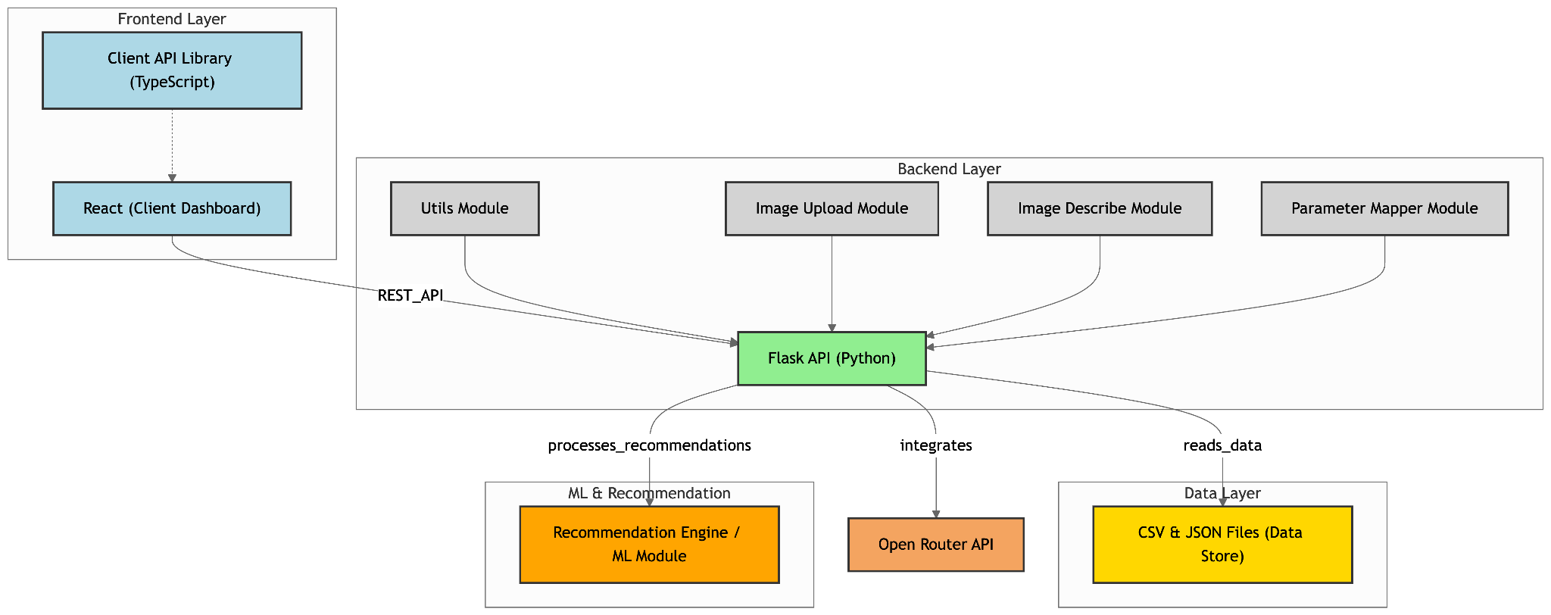 *System architecture*

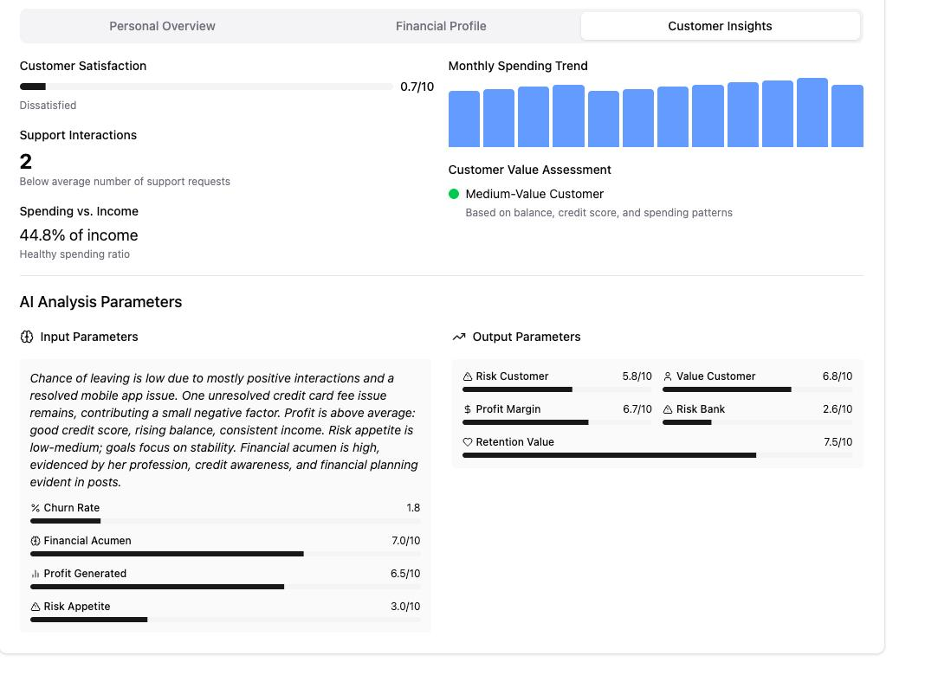

*Generated customer insights (parameters)*

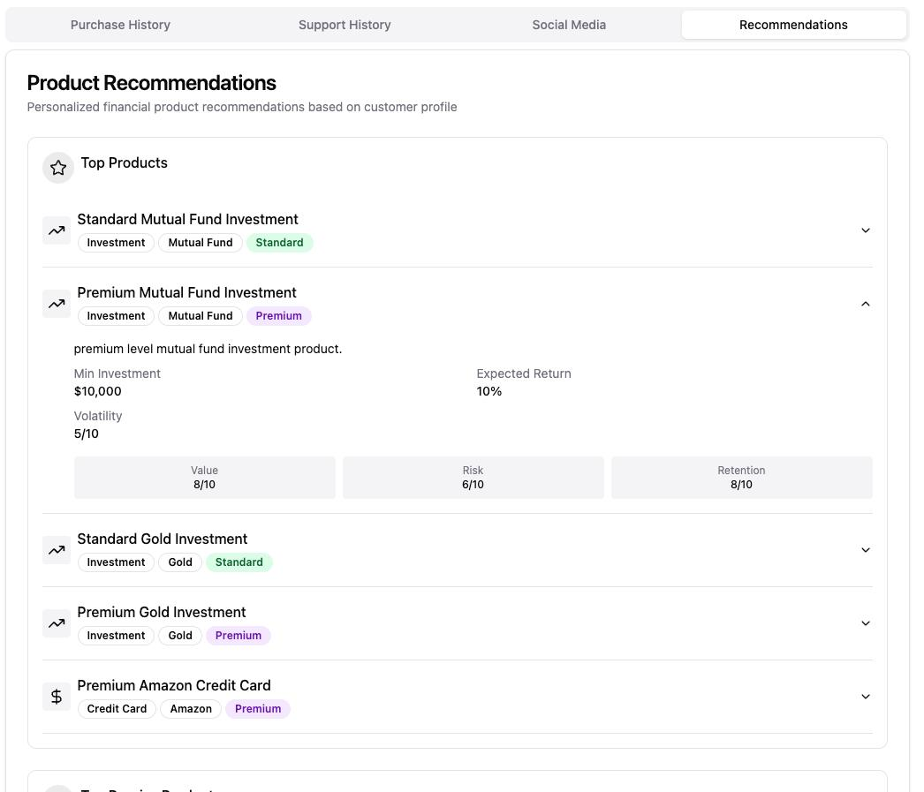

*Product Recommendations*

**7. Benchmarking & Evaluation**

**7.1 Internal Performance Evaluation**

Our solution demonstrates strong internal performance by effectively generating relevant and personalized recommendations using a multi-step filtering approach:

* Dynamic Recommendation Workflow:
  + The system uses the concepts of Mahalanobis distance and weighted vector distance to identify the most relevant products and services based on customer attributes.
* Real-time Adaptability:
  + The solution dynamically incorporates real-time data (from customer profiles and sentiment analysis) during the recommendation process.
  + This ensures the system adjusts recommendations based on recent customer interactions, improving relevance.
* Efficient Execution:
  + The use of Flask APIs and streamlined data handling ensures that recommendations are generated with minimal latency, making the system suitable for real-time customer interactions.

**7.2 Expected Business Impact**

Our solution offers significant business benefits through enhanced personalization and customer engagement:

* Improved Customer Retention:
  + By identifying churn risks and dynamically tailoring offers, the solution helps banks proactively engage at-risk customers.
  + This can lead to higher retention rates and reduced customer attrition.
* Increased Product Adoption:
  + The system matches products with high revenue potential to customers with corresponding financial profiles, boosting the likelihood of product adoption.
  + This can contribute to increased cross-selling and upselling opportunities.
* Enhanced Customer Experience:
  + With sentiment-driven recommendations, the system provides more relevant and context-aware suggestions, improving customer satisfaction.
  + Personalized recommendations based on real-time preferences can enhance loyalty and trust.

**8. Challenges & Learnings**

**8.1 Challenges Faced**

1. Data Quality Issues

* Inconsistent customer data caused incorrect customer parameters, which in turn gave irrelevant recommendations
* Solution: Refine our prompts and manually sift through the data to make it cohesive.

2. Model Explainability

* The complex metric mapping made it difficult to interpret why certain products were recommended.
* Solution: Added explanatory insights with metrics like churn probability and financial potential alongside recommendations.

**8.2 Key Learnings**

1. Real-Time Adaptability Matters: Dynamic sentiment analysis improved recommendation accuracy by adapting to changing customer behavior.

2. Multi-Metric Mapping Boosts Relevance: Using four customer metrics enhanced the accuracy and business value of recommendations.

3. Multi-Modal Expansion is Promising: Adding voice and image inputs could significantly enhance future personalization capabilities.

**9. Business Strategy Recommendations**

Our system can help the bank enhance customer retention, maximize revenue, and deliver highly personalized experiences.

**9.1 Customer-Centric Personalization Strategy**

1. Hyper-Personalized Product Offerings: The system recommends tailored financial products based on customer profiles, transactions, and sentiment analysis, driving higher adoption rates.

2. Sentiment-Driven Engagement: Real-time sentiment analysis from customer support and social media detects mood shifts, and helps recommend products appropriately.

**9.2 Revenue Growth & Profitability**

1. Data-Driven Revenue Optimization

* The system prioritizes high-revenue products for financially capable customers, maximizing bank profits.
* Example: High-potential customers receive long-term investment product offers, ensuring consistent revenue.

2. Reduced Customer Churn

* Churn probability metrics identify at-risk customers.
* Proactive, tailored incentives (e.g., discounted rates) reduce attrition and revenue loss.

**9.3 Enhanced Operational Efficiency**

1. Automated Recommendation Pipeline

* Our AI-driven engine automates customer targeting, reducing manual efforts and boosting efficiency. Real-time recommendations speed up customer acquisition and engagement. For example: During support calls, the system suggests relevant retention offers instantly.

**10. Conclusion & Future Scope**

**10.1 Conclusion**

Our AI-driven hyper-personalization system effectively delivers tailored financial product recommendations to customers by:

* Multi-dimensional customer profiling: Real-time metrics (churn rate, financial potential, risk appetite) from customer demographics, transactions, and sentiment data.
* Contextual Product Mapping: Matching customer metrics with product attributes using Mahalanobis and weighted vector distance models.
* Dynamic sentiment-driven refinement: LLM-powered sentiment analysis continuously adapts recommendations based on customer mood.
* Efficient backend and UI: A Flask-based backend ensures real-time data retrieval, while the UI offers intuitive profile visualization.

**10.2 Future Scope**

The solution can be further enhanced with the following improvements:

1. Multi-modal Personalization: Expanding to voice and video analysis for richer insights (e.g., voice tone detection during support calls).

2. Real-time Adaptive Learning: Introducing reinforcement learning (RL) for continuous human feedback-driven recommendation improvements.